Phase 3 Writeup

**Project Statement.**

Create a dynamic and responsive e-healthcare web application for ordering medicines of different categories.

Ideation: I have created two tables- One named Category (to store Category of the medicine) and another named Medicine (to store the medicine details)

I planned to create two Areas, one for Admin and another for User.

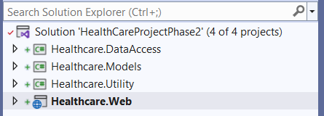

Figure 1 – Solution Explorer

The Solution is Web Application

1. Healthcare.DataAccess

It consists of Data folder.(having applicationDb context file), Repositories and ViewModels folder.

1. Healthcare.Models

It consists of the various Models(table)

1. Healthcare.Web

It consists of the Controllers,Areas, Views folders.

**ADMIN USECASES**

1. **View All Categories of Medicine**

**Endpoint**: <https://localhost:5001/index>

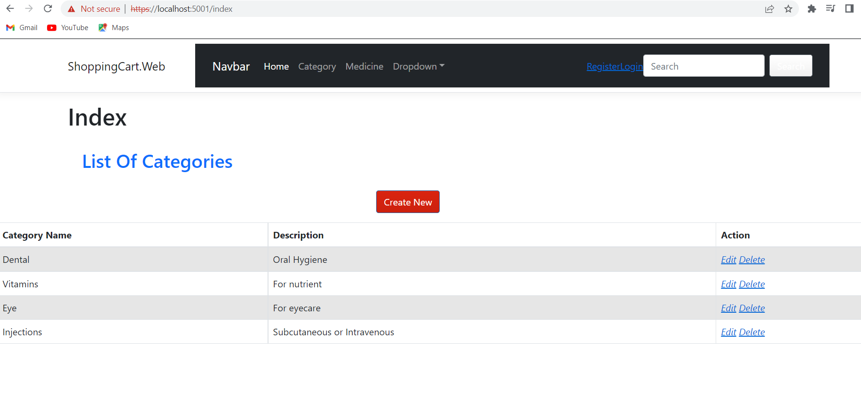

1. Add a New Category

Endpoint: <https://localhost:5001/Admin/category/CreateUpdate>

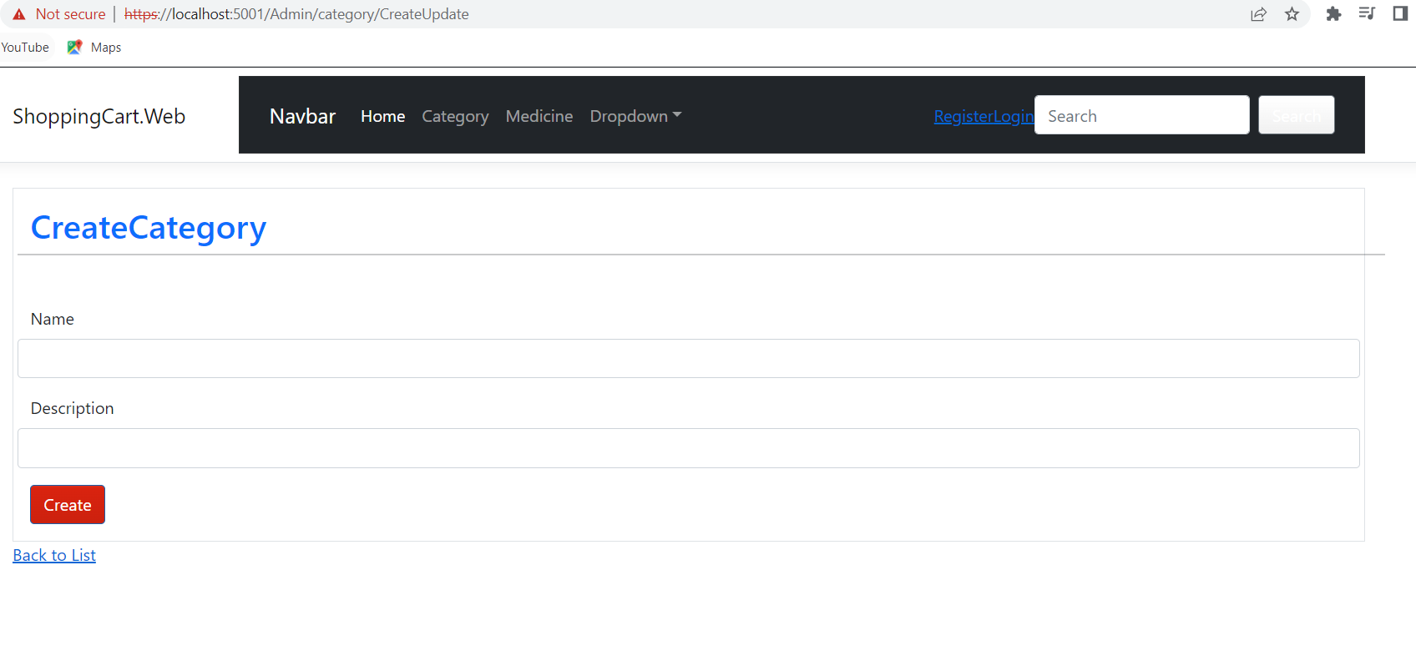

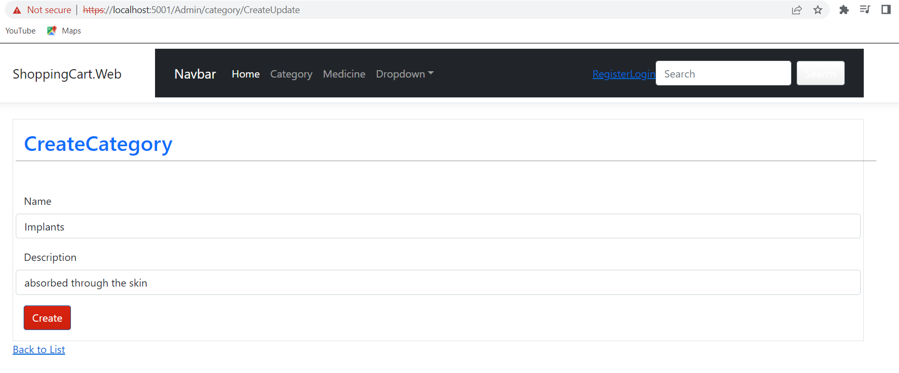

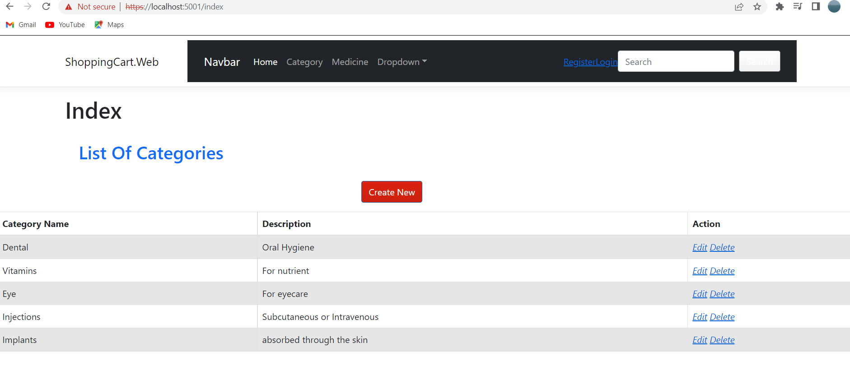

1. Edit a Category

Endpoint: <https://localhost:5001/Admin/category/CreateUpdate/4>

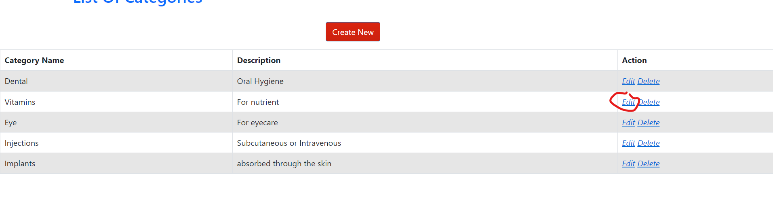

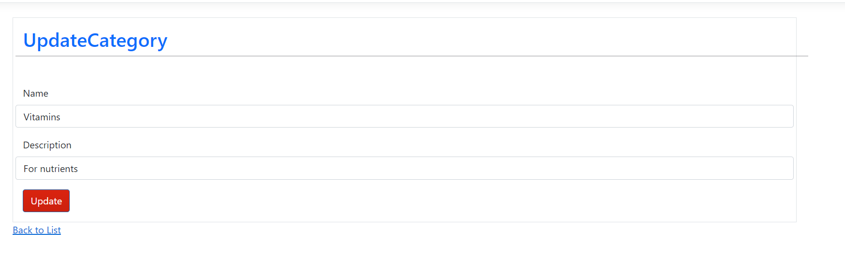

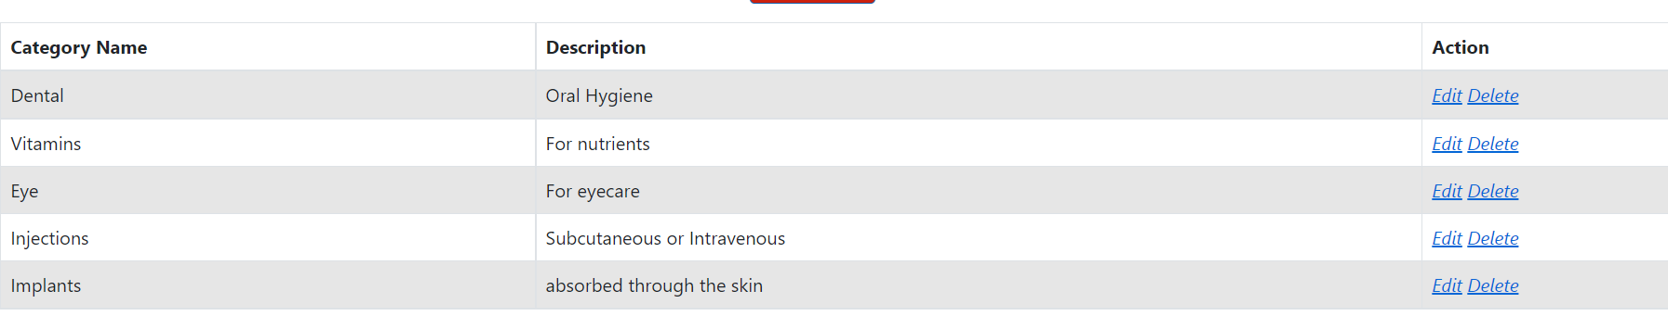

1. Delete a Category Record

Endpoint: https://localhost:5001/Admin/category/Delete/7

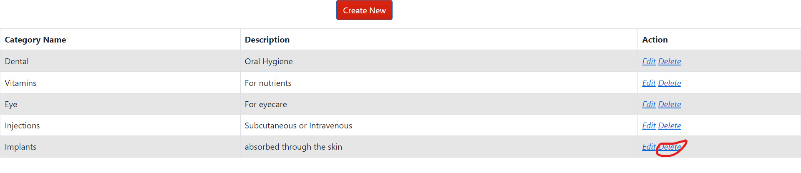

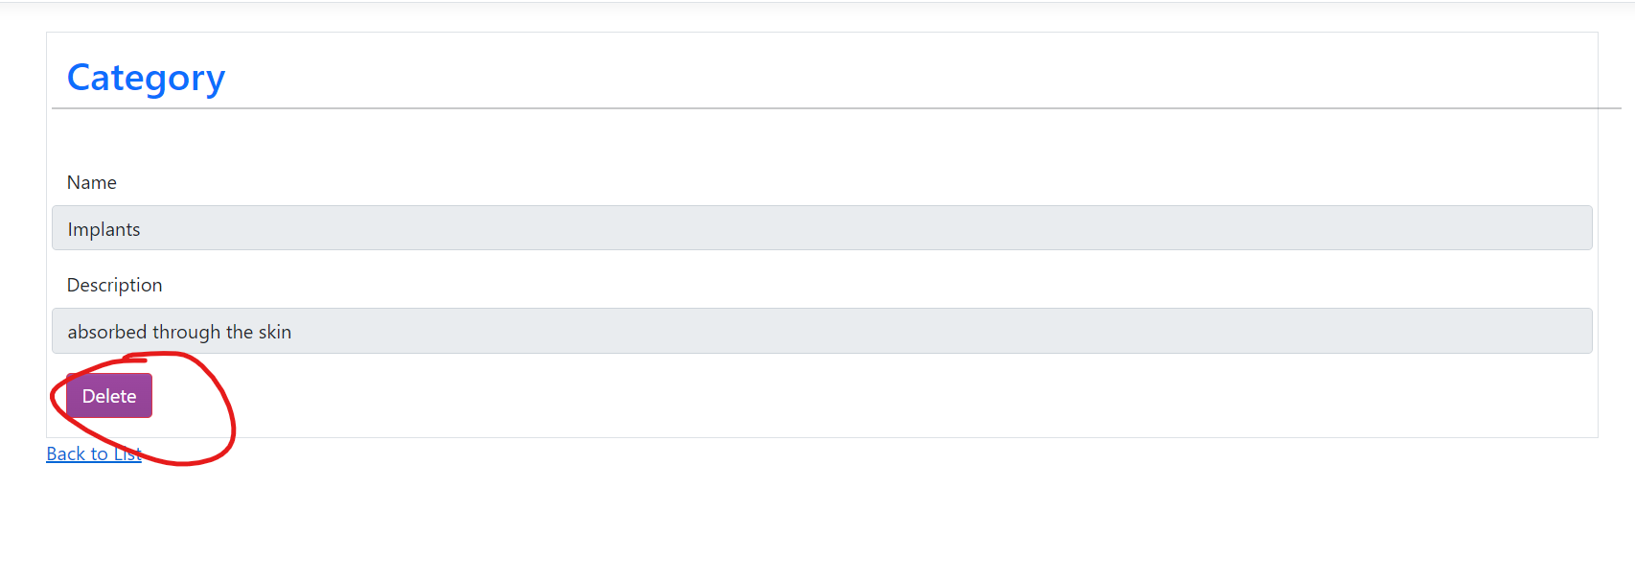

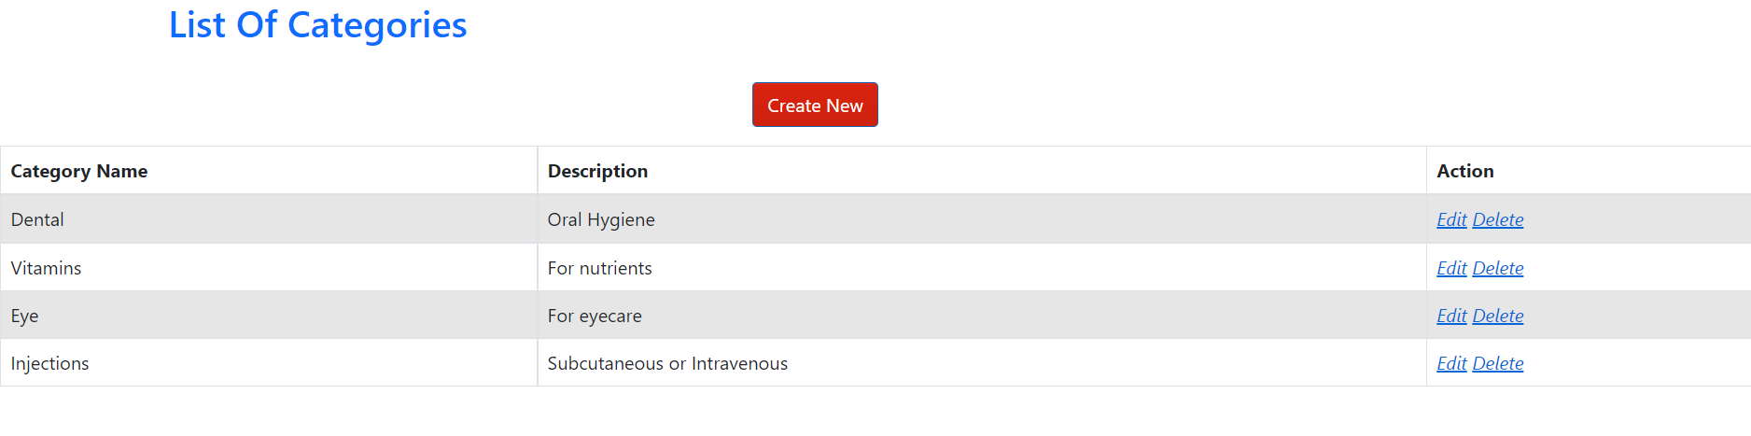

1. View All Medicines

Endpoint: <https://localhost:5001/Admin/Medicine>

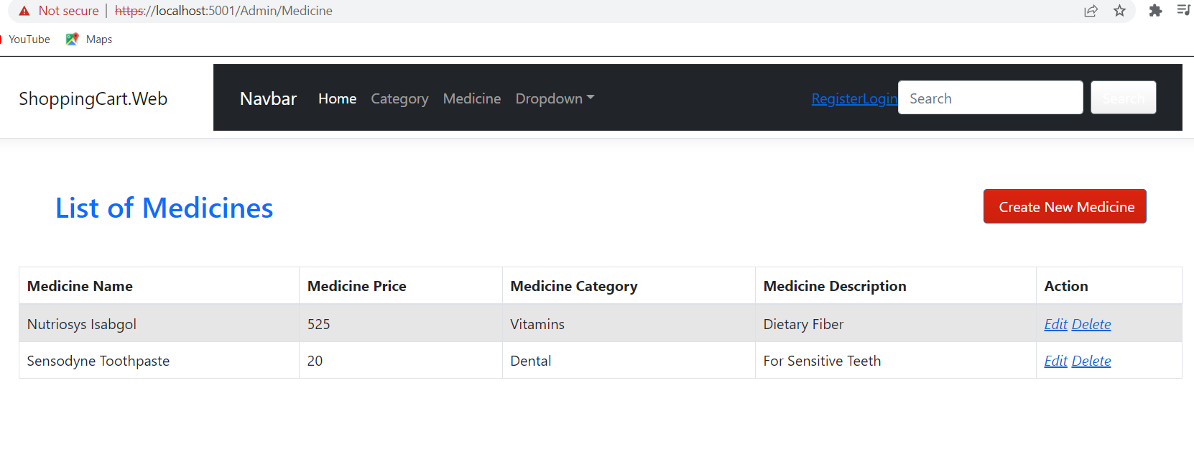

1. Create a Medicine Record

Endpoint: https://localhost:5001/Admin/Medicine/CreateUpdate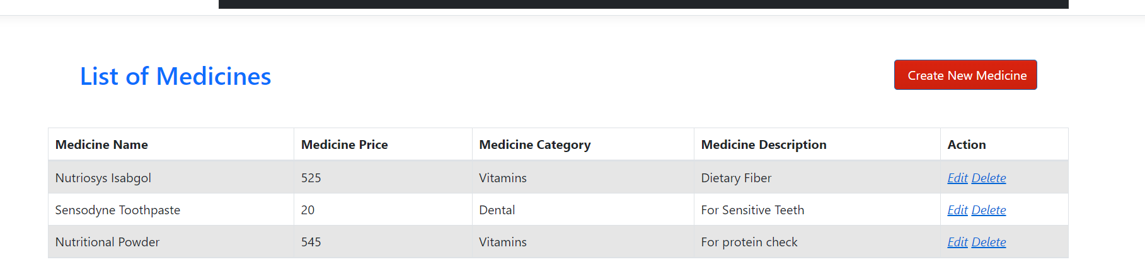

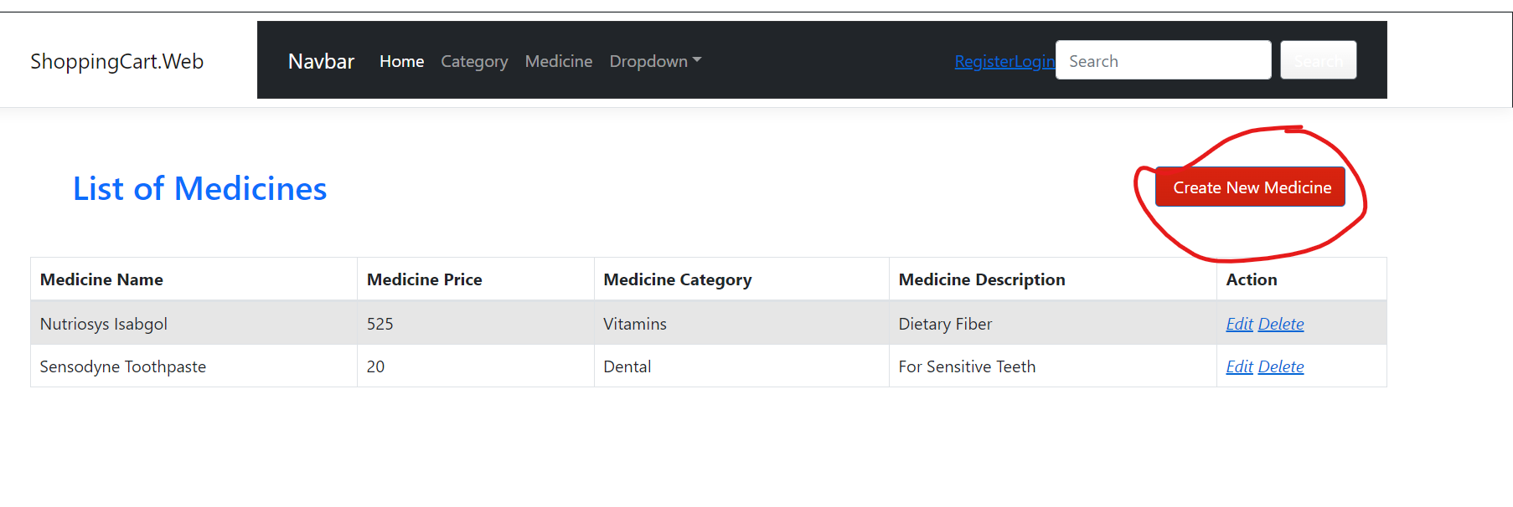

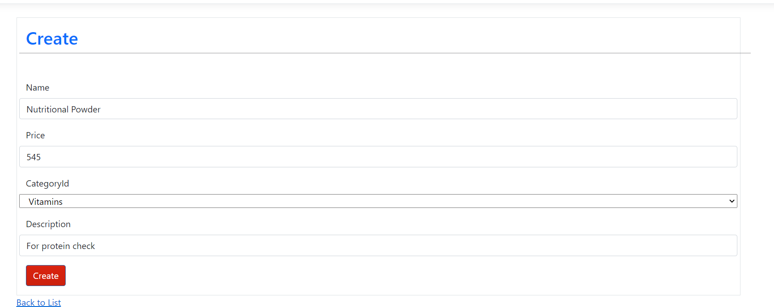



1. Edit a Medicine Record

Endpoint: <https://localhost:5001/Admin/medicine/CreateUpdate/4>

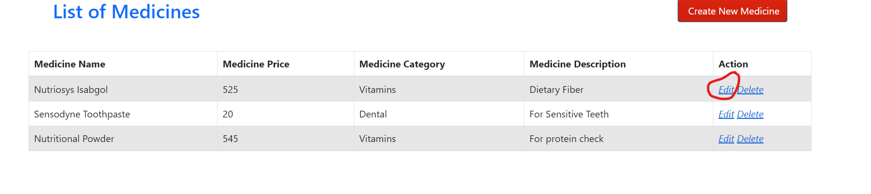

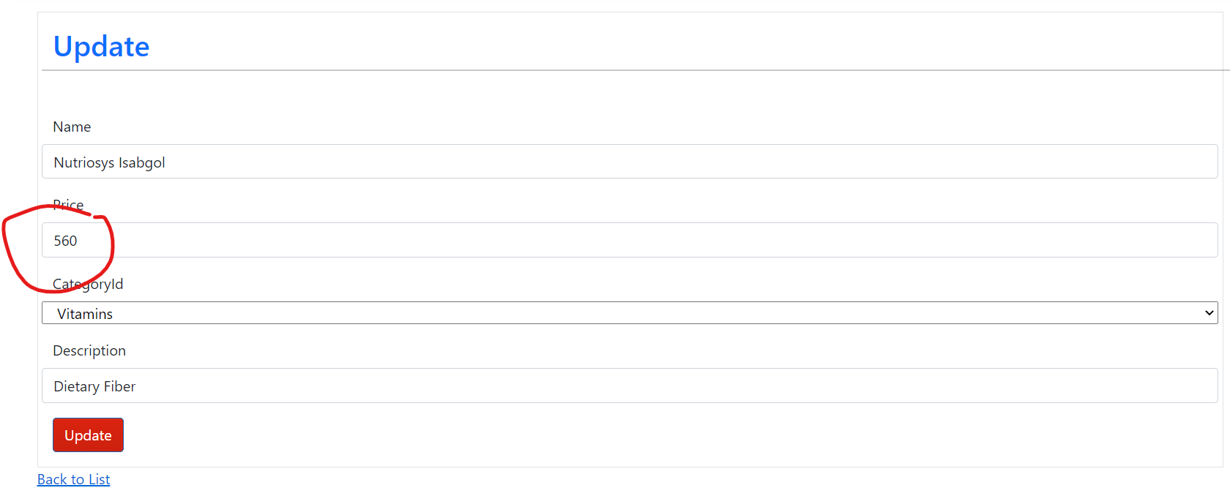

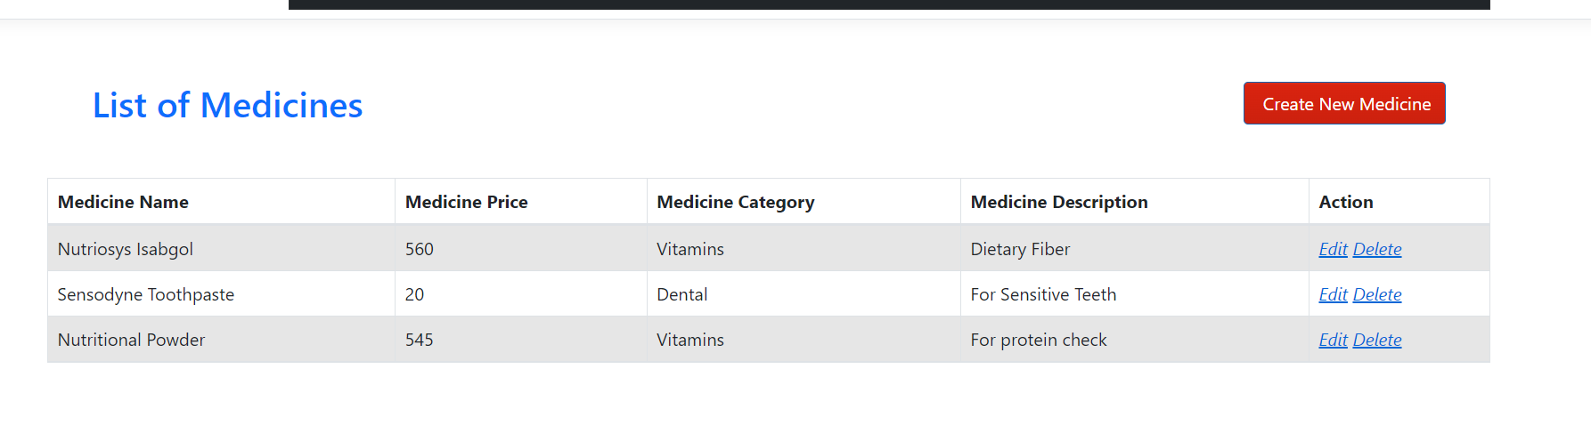

1. Delete a Medicine Record

Endpoint: <https://localhost:5001/Admin/medicine/Delete/6>

